**The Ark Documentation.**

**Barcode Labels.**

Log in and select your study.

Once you have chosen your study we will see the following functions. Click the LIMS function in the top row.

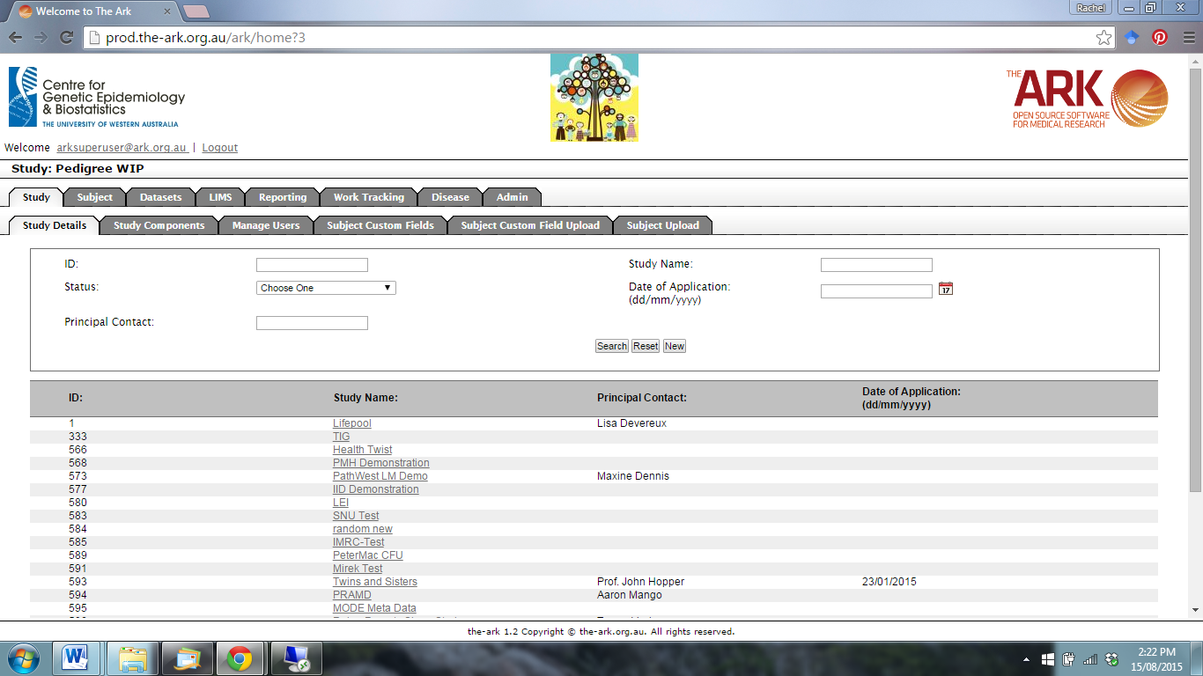

The following page will appear. Select the Barcode Labels function.

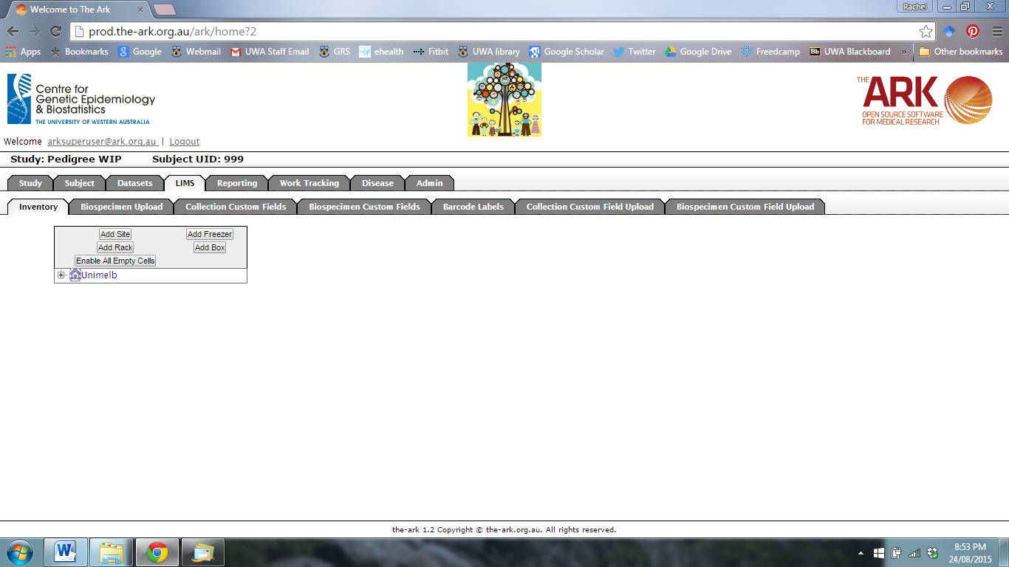

The following page will appear.

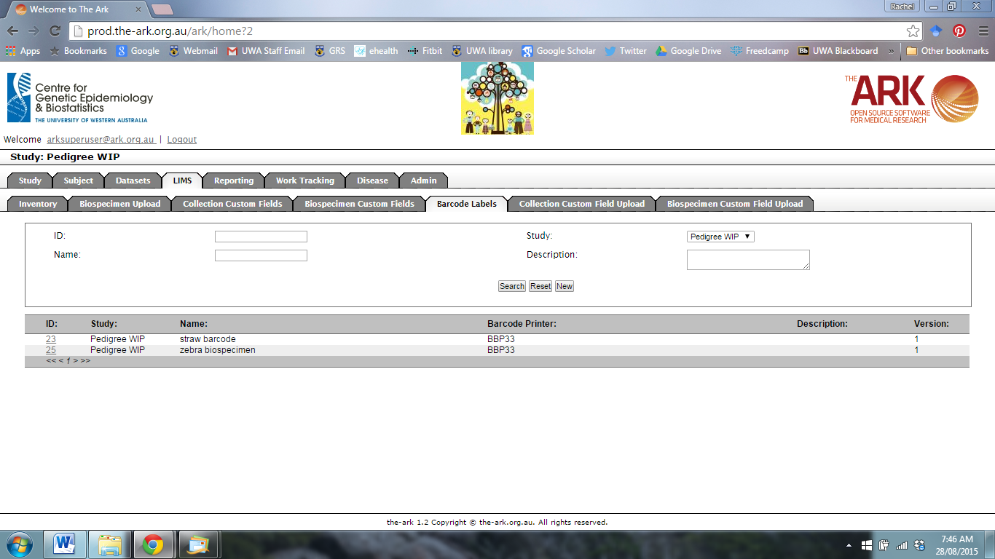

To add a new barcode label, click new.



The following page will appear.

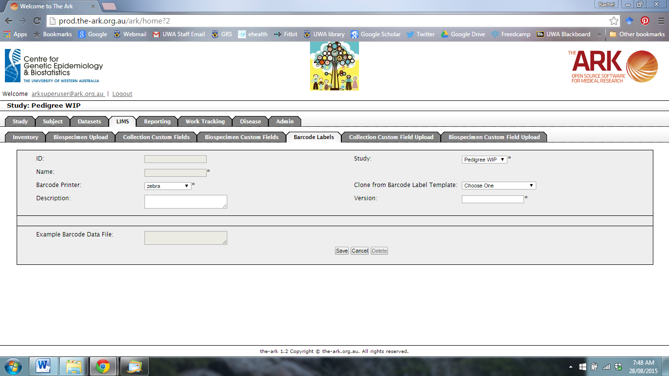

Select your Study and the Barcode Printer from the drop-down menu.

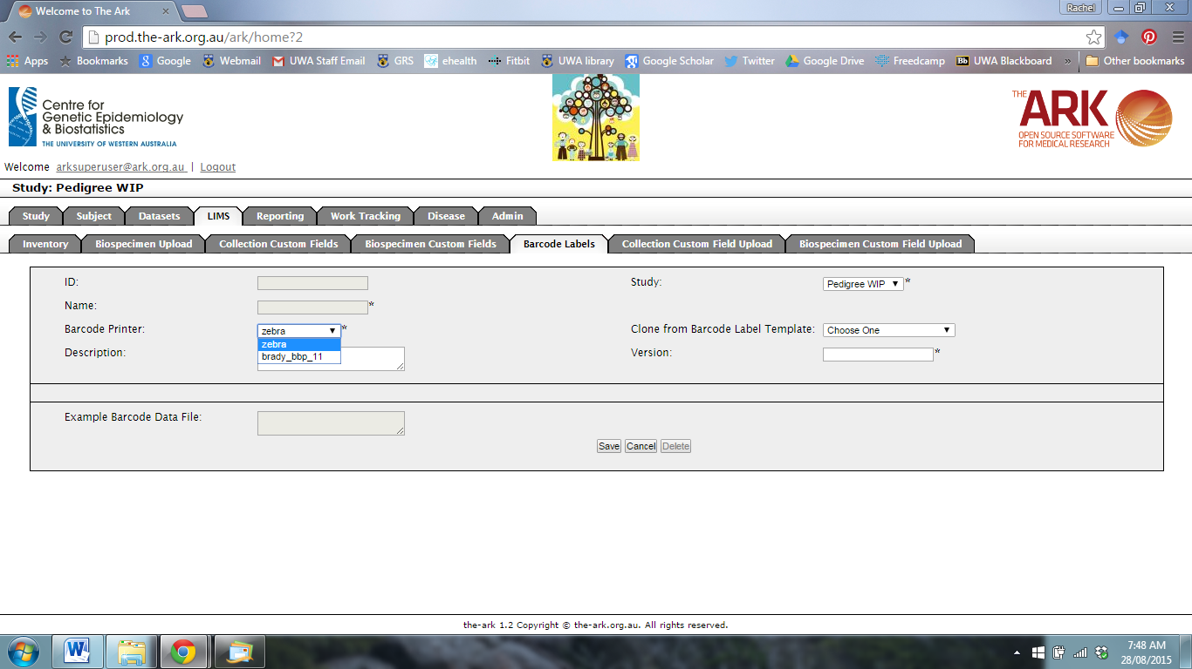

You can also select a Barcode Template.

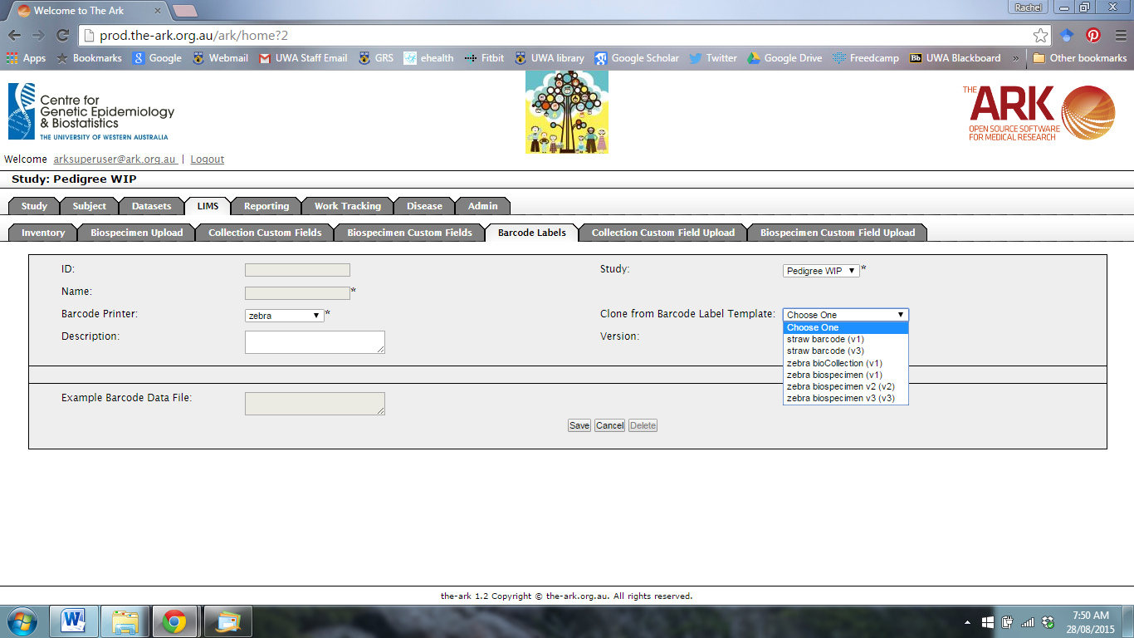

When you have chosen a template, the Example Barcode Data File will show a preview of the label.

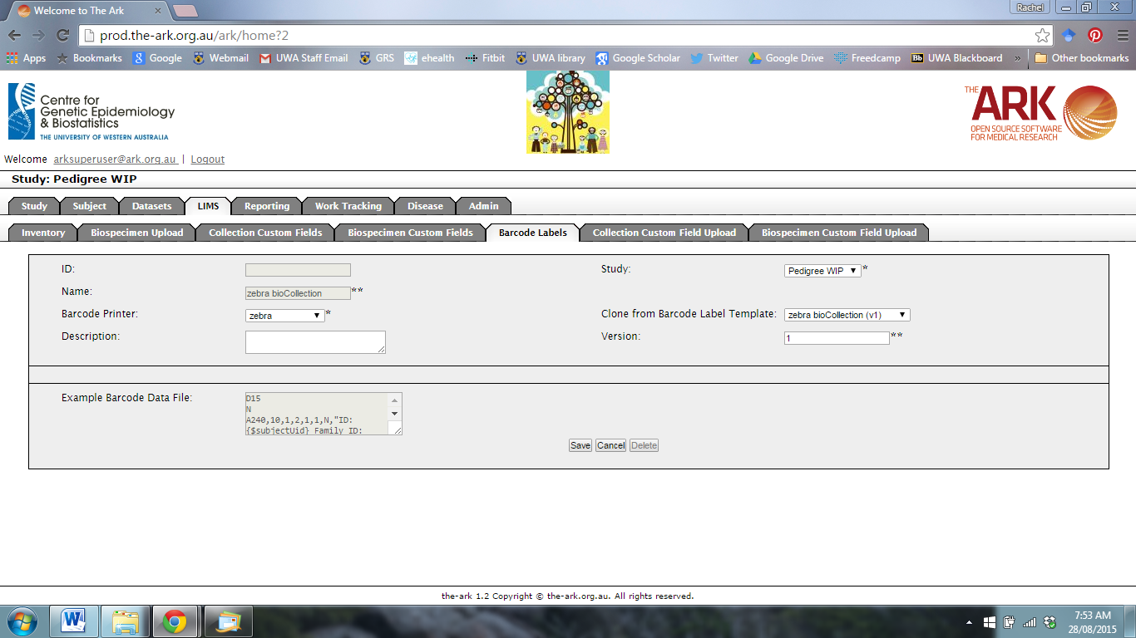

Add in the new Version name.

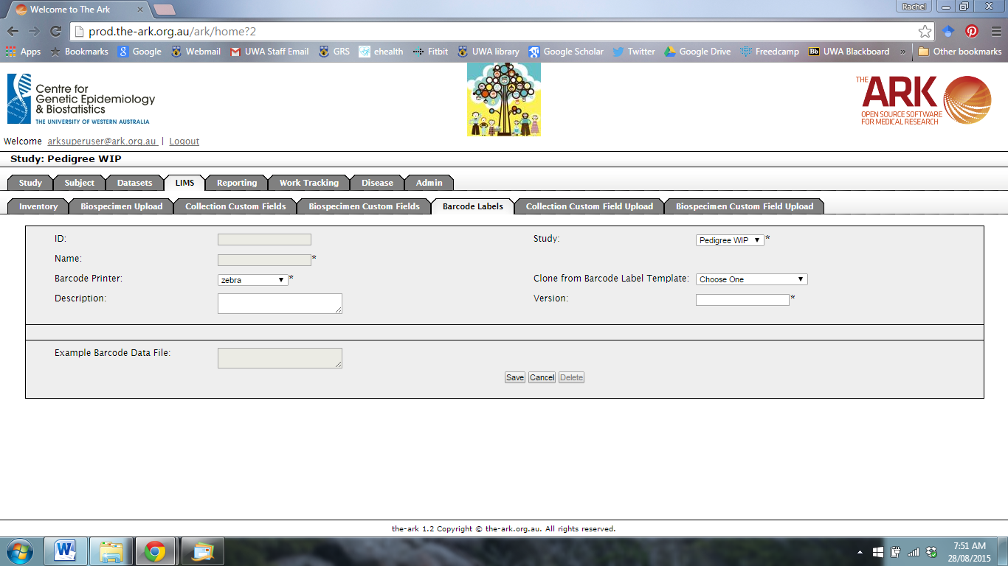

When you have finished, click Save.

When you click Save, the following page will appear.

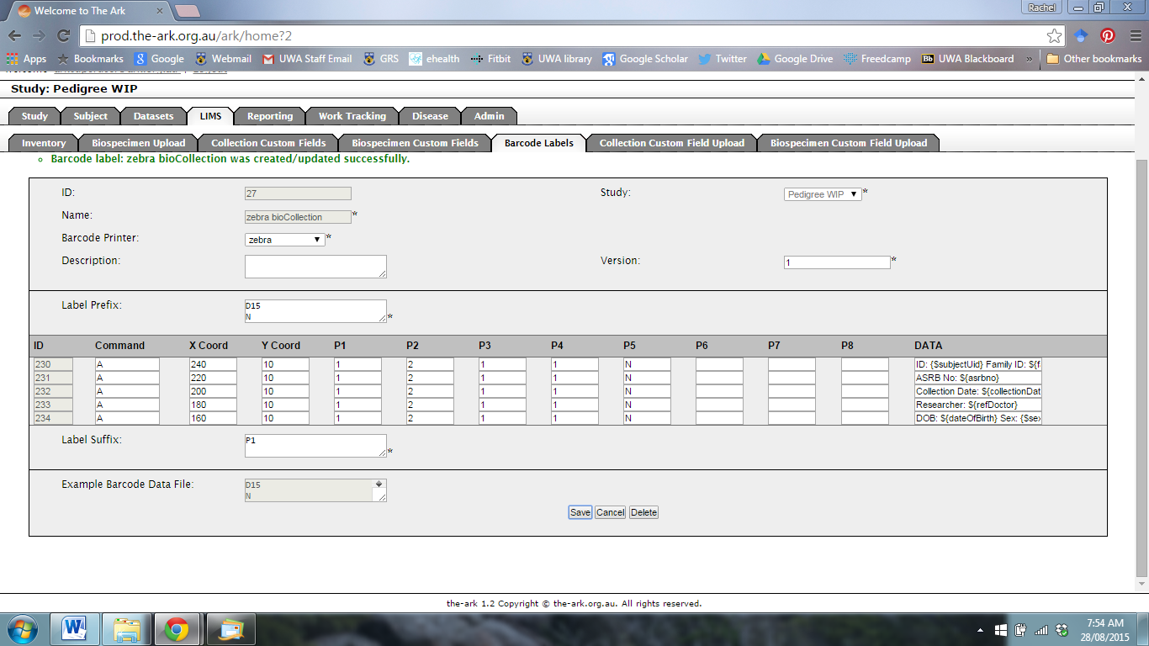

If you are happy with the barcode label, click Save.